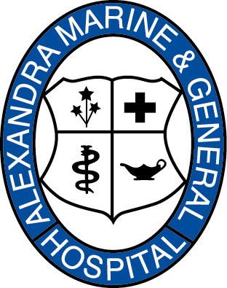
ALEXANDRA MARINE AND GENERAL HOSPITAL
120 Napier Street
Goderich, ON N7A 1W5
(519) 524-8323 Telephone
(519) 524-8504 Fax
Email: amgh.administration@amgh.ca

Looking up a Goderich (Alexandra Marine & Gen. Hospital)
Patient in CENTRICITY ZFP

**Please note that you cannot find Goderich Patient images in Cerner Powerchart as we are using Meditech as our hospital information system. However, we are on exactly the same PACS system as you are. **

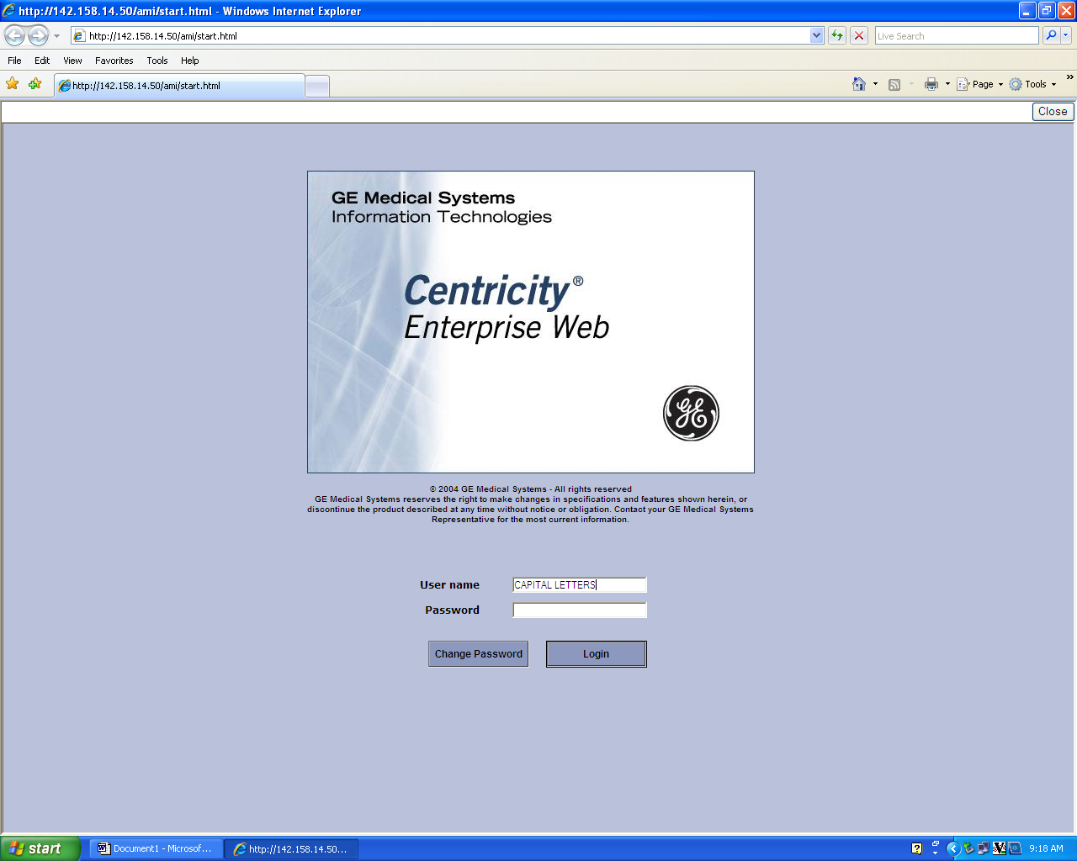

- Check that you have the CAPITAL LOCK ON
- Enter your User Name
- Enter your password
- In the Domain Window Dropdown box - Choose Alexandra Marine & General Hospital (Goderich)

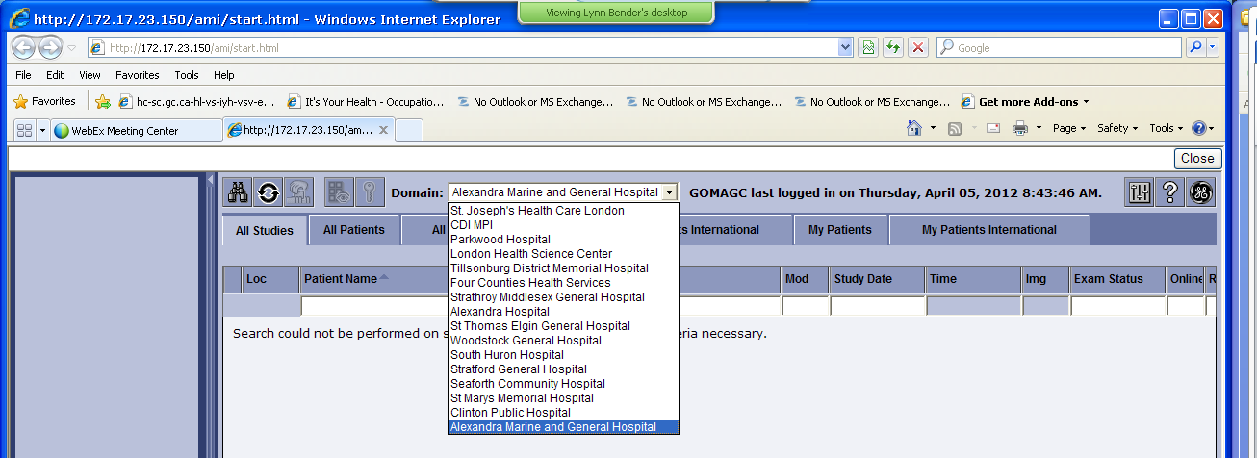

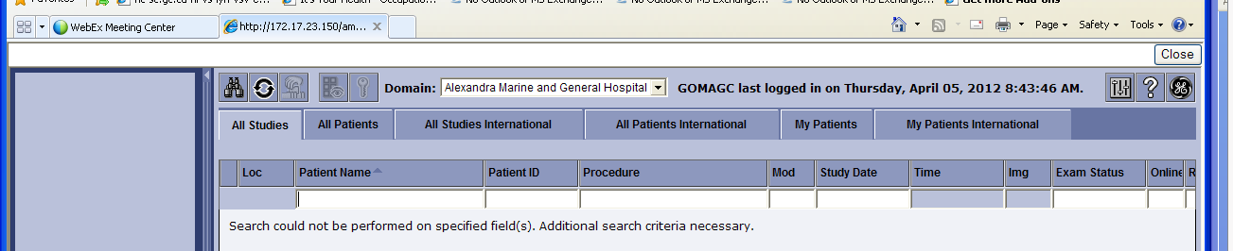

- You can search by name or Goderich MRN number available on the top of a printed report(s)
  - Enter Name or Number but not both.
  - Goderich Patient MRN begins with a G followed by a zero or 1

- Note if you use the name it must be SURNAME, (Space) Given Name

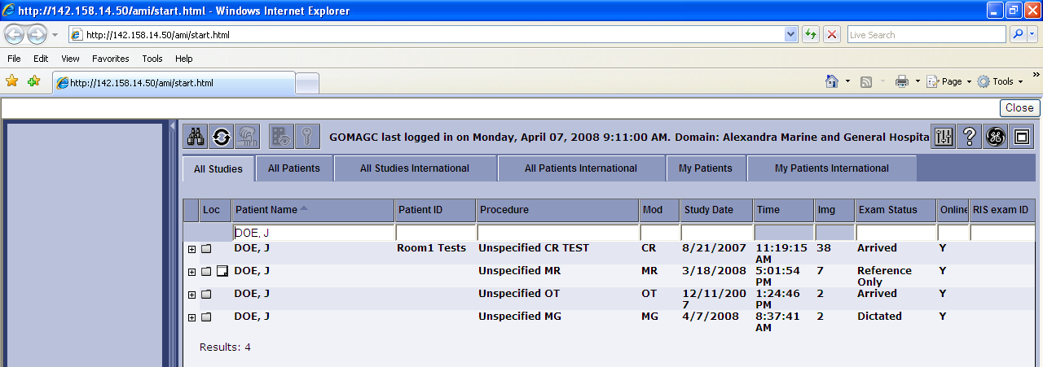

Double click on the line of the study you want.

Patient Name:___________________________________

Goderich MRN: ________________________________________

***If you are unable to bring up the Goderich patient please contact your local PACS support.

London: UH, VH, SJ, PKWD call Help Desk 44357 or 1-519-685-8500 (outside line)
Strathroy: (519-245-1550) ext 5546 and ask for PACS Support.
Exeter: 519-235-5163 and ask for PACS Support.
Goderich: 519-524-8689 ext 5479

**Please note that you cannot find Goderich Patient images in Cerner Powerchart as we are using Meditech as our hospital information system. However, we are on exactly the same PACS system as you are. Our images can be seen in Full version GE Centricity PACS, Centricity ZFP (Zero Foot Print) and ONE VIEW **

